

GENERAL PROCEDURE

for
MAGNETIC PARTICLE TESTING

DOCUMENT NUMBER: | IQMS-MT-P-001
REVISION: | 00
DOCUMENT DATE: | 31 MAY 2017

18 Greybeard Road, Sandrift-North, Milnerton, 7441
Tel / Fax: +27(0) 21 555 2973 Mobile: +27(0) 79 957 2869
Email: cpt@iqms.co.za Website: www.iqms.co.za
Contents
1. PURPOSE 3
2. SCOPE 3
3. REFERENCING CODE SPECIFICATIONS 3
4. DEFINITIONS AND ABBREVIATIONS 3
5. NORMATIVE REFERENCES 4
6. REQUIREMENTS 4
6.1 Safety 4
6.2 Prerequisites 4
6.3 Precautions and Limitations 4
6.4 Personnel Requirements 5
6.5 Equipment Requirements 5
6.6 Location and Component Identification 5
6.7 Examination Medium 5
6.8 Techniques 6
6.9 Surface Preparation 6
6.10 Surface Contrast Enhancement 6
6.11 Method of Examination 7
6.12 Excess Particle Removal 7
6.13 Direction of Magnetization 7
6.14 Examination Coverage 8
6.15 Interpretation 8
6.16 Evaluation 8
6.17 Documentation 8
6.18 Demagnetization 9
6.19 Post-examination Cleaning 9
APPENDIX 1 - ASME B31.1 2014 10
APPENDIX 2 - ASME B31.3 2014 12
APPENDIX 3 - ASME VIII 2015 13
APPENDIX 4 - AWS D1.1 2010 17
APPENDIX 5 - SAMPLE REPORT 18
PLEASE NOTE
This Document replaces all previous discussions, understandings and revisions of this written procedure for the Magnetic Particle Testing utilized by IQMS Group.

PURPOSE

This Procedure details the method to perform Magnetic Particle Testing with yokes by Authorized Personnel on behalf of IQMS GROUP.

SCOPE

Applicable to all ferromagnetic materials which includes product forms of welds, castings and forgings when the Procedure Code is:

ASME V (2015) | ASME Boiler and Pressure Vessel Code, Section V: Non-Destructive Examination
ASME V (2015) | Article 7: Magnetic Particle Examination
ASME V (2015) | Article 25 SE709: Standard Guide for Magnetic Particle Testing

REFERENCING CODE SPECIFICATIONS

The applicable version and addendum of the referencing code specifications shall be stipulated by the client, AND a working copy may be requested by the Company from the client prior to conducting work under this procedure.

ASME B31.1 (2014) | Power piping
ASME B31.3 (2014) | Process Piping
ASME VIII (2015) | ASME Boiler and Pressure Vessel Code, Section VIII, Div 1: Rules for Construction of Pressure Vessels
AWS D1.1 (2010) | Structural welding code

(Usually the latest/ current edition of a Code/Specification is applicable. Specific editions of the Codes/Specifications used, must be specified on the Report Sheet as the Customer may have specific requirements.)

DEFINITIONS AND ABBREVIATIONS

NDT | Non-Destructive Testing
MT | Magnetic Particle Testing
Technician | A qualified MT Level II or III Technician authorized by the Company in accordance with IQMS-WP-001.
The Company | IQMS GROUP
AC | Alternating Current
DC | Direct Current
UV | Ultra Violet light with nominal wavelength of 365nm (commonly called black light)

NORMATIVE REFERENCES

IQMS -WP-001 | Written Practice for the Qualification, Internal Certification and Authorization of NDT Personnel.
IQMS -WP-002 | Written Practice for the Performance of NDT Equipment.

REQUIREMENTS

6.1 Safety

- Extreme caution shall be exercised as Magnetic Particle materials can be flammable and/or emit hazardous and toxic vapor.
- Any additional manufacturer’s safety precautions must be observed.
- Prior to the commencement of work, all safety and regulatory safety standards as specified by the location of work (E.g. Refineries, Power stations, manufacturing, workshops, etc.) must be adhered to.
- Before any electrical equipment is used, the technician shall satisfy himself that there shall be no danger or hazard from fire as a result of any overheating or sparking.
- All equipment shall be certified as electrically safe prior to use.
- It is essential to ensure that adequate ventilation in confined areas is supplied.
- The use of an O2 Monitor (Oxygen Monitor) may be a requirement at certain work locations. Some work locations may require that the client provides an oxygen test prior to a vessel entry. Adequate ventilation is of utmost importance when performing a Magnetic Particle Inspection in confined spaced areas.
- The use of extraction fans may be necessary. These conditions must be discussed and a predetermined pre-job discussion and safety plan shall be agreed upon between the company and client prior to the commencement of work.
- Avoid contact with the UV lamp housing as it becomes extremely hot in use.
- All permits shall be completed in full when required by the client or site of work.
- Wet Floors: Slipping on a floor wetted with Magnetic Particle medium suspension may be possible. Exercise caution during the inspection to this regard. Ensure proper drainage of excess waste medium.

6.2 Prerequisites

Prior to any examinations performed, the technician shall ensure that all work permits, safety regulations and documented requests from client is in place and that all involved personnel is informed of the procedure to be followed.

6.3 Precautions and Limitations

The magnetic particle examination method may be applied to detect cracks and other discontinuities on the surfaces of ferromagnetic materials.

Maximum sensitivity will be to linear discontinuities orientated perpendicular to the lines of flux. For optimum effectiveness in detecting all types of discontinuities, each area is to be examined at least twice, with the lines of flux during one examination approximately perpendicular to the lines of flux during the other.

6.4 Personnel Requirements

All personnel performing MT, Evaluating and/or reviewing the test results shall be Level II or Level III Technicians authorized in accordance with the requirements of IQMS-WP-001. Level I personnel may provide assistance under the direct supervision of a Level II technician.

6.5 Equipment Requirements

All equipment used for MT shall be in a good working order and calibrated as stipulated in IQMS-WP-002.

6.5.1 Yokes:
- The magnetizing power of yokes shall be verified prior to use each day the yoke is used.
- The magnetizing power of yokes shall be verified whenever the yoke has been damaged or repaired.
- Each alternating current electromagnetic yoke shall have a lifting power of at least 10 lb (4.5 kg) at the maximum pole spacing that will be used.
- Each direct current or permanent magnetic yoke shall have a lifting power of at least 40 lb (18 kg) at the maximum pole spacing that will be used.
- Each weight shall be weighed with a scale from a reputable manufacturer and stenciled with the applicable nominal weight prior to first use. A weight need only be verified again if damaged in a manner that could have caused potential loss of material.

6.5.2 Magnetic Field Indicators:
- When required by the client, a magnetic field indicator shall not be used to verify the strength of the magnetic field of the yoke but only as a confirmation of the magnetic field direction.
- A Burmah Castrol strip, Berthold or ASME gauge may be used between the yoke poles on the area of interest in at least three directions, 45°, 90° and 135° to the expected magnetic field direction when :
  - Inspecting configuration welded areas such as “T” pieces, Nozzles or attachment welds.
  - Both yoke poles (flat surfaces) do not make 100% contact with test surface.
- In all three prescribed positions of field indicator placements, the lines on the indicator shall be clearly visible. If not, another NDT method should be considered and only employed with the permission of the client.

6.6 Location and Component Identification

- Each weld or component shall be identified on a work request together with an inspection package. At each location a physical identification should be present, i.e. Plant Location Code (PLC).

- In cases where the inspection package and physical identification nomenclature cannot be reconciled, NO inspection shall be performed until resolution is provided by the Client.

- Where temporary identification is allowed, the operator shall ensure that the type of marking will remain present for any period of re-work, should repairs be necessary. The operator shall establish a zero reference datum related to some prominent feature of the item (e.g. Top Dead Centre), which shall be detailed in the inspection report.

6.7 Examination Medium

- Different ‘Families’ of consumables from different manufacturers shall not be inter-mixed.

- Either Colour contrast (wet and dry) or fluorescent (wet) magnetic particles may be utilized. Wet magnetic ink shall be used as preference.

- Particle size shall be as per Table below:

Type | US Standard Sieve #  (98% Pass Through) | Typical Particle Size
Visible Wet | No. 325 (45 µm) | 1 - 20 µm
Fluorescent Wet | No. 325 (45 µm) | 1 - 12 µm
Visible Dry | No. 80 (180 µm) | - - 160 µm

- The expiration dates of all consumables shall be checked and may not be used if expired. The expiry dates of consumables and batch numbers shall be recorded on each report as used.

- White colour contrast paint shall be applied to area of interest in a thin even layer and allowed to dry prior to application of wet colour contrast magnetic particles during inspection.

- When using the wet particle techniques, material surface temperature shall not exceed 50°C during inspection.

- When using the dry particle technique, temperatures shall not exceed the allowance by the manufacturer of the particles.

6.8 Techniques

Either colour contrast visible or fluorescent Magnetic Particles shall be used with one of the following Continuous Magnetic Particle Testing processes:

- AC Yoke Technique
- DC/Permanent Yoke Technique

6.9 Surface Preparation

- Areas to be examined plus 50 mm on either side shall be clean and dry prior to inspection.

- Scale, weld flux and weld spatter shall be removed from the component by the relevant authorities using an approved method prior to inspection.

- Wire brushing and the solvent spray-on, wipe-off technique may be used by the MT technician to remove any organic contaminants which may interfere with the examination.

- The MT technician shall avoid the use of any power tools for surface preparation unless given written permission by Customer’s Authorities or specified in a documented request for inspection by the client.

- The technician shall not attempt any inspections on a surface that does not conform to the above mentioned specifications.

6.10 Surface Contrast Enhancement

When non-magnetic coatings are temporarily applied to uncoated surfaces, it shall be only in amounts sufficient to enhance particle contrast. The use of contrast enhancement coatings are only permitted when the visible methods are applied and may not be applied to surfaces with temperatures exceeding 50°C.

6.11 Method of Examination

- Inspection shall be done by the continuous method.

- At least two separate inspections shall be performed on each area, where the second inspection shall be approximately perpendicular to that during the first inspection.

- Inspection of each area shall be done directly between yoke poles in each direction of pole positions.

- All inspections shall be conducted with sufficient overlap to ensure 100% coverage is obtained. Re-inspect all areas showing possible false or non-relevant indications.

- Broad areas of particle accumulation which might mask relevant discontinuities shall be cleaned and re-inspected.

- Dry Particles:
The magnetizing current shall remain on while the examination medium is being applied and while any excess of the examination medium is removed.

- Wet Particles
Wet particles applied from aerosol spray cans may be applied before the application of magnetizing current. Wet particles may be applied during the application of magnetizing current if they are not applied directly to the examination area and are allowed to flow over the examination area or are applied directly to the examination area with low velocities insufficient to remove accumulated particles.

6.12 Excess Particle Removal

Accumulations of excess particles in examinations may be removed with light blowing, the magnetizing current shall be maintained while removing the excess particles. Alternatively, area of should be cleaned of particle accumulations and re inspected to ensure no masking of relevant indications.

6.13 Direction of Magnetization

At least two separate examinations (Criss-Cross method) shall be performed on each area. During the second examination, the lines of magnetic flux shall be approximately perpendicular to those used during the first examination.

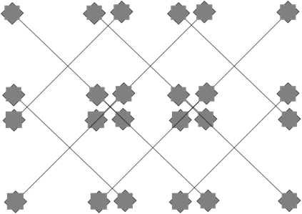

6.14 Examination Coverage

All examinations shall be conducted with sufficient field overlap to ensure 100% coverage at the required sensitivity.

6.15 Interpretation

- The interpretation shall identify if an indication as false, non-relevant, or relevant. False indications shall be re-tested in order to detect whether they are relevant or not and non-relevant indications shall be proven as non-relevant. Interpretation shall be carried out to identify the locations of indications and the character of the indication.

- Visible (Colour Contrast) Magnetic Particles:
Surface discontinuities are indicated by accumulations of magnetic particles which should contrast with the examination surface. The colour of the magnetic particles shall be sufficiently different than the colour of the examination surface. A minimum light intensity of 100 fc (1076 Lx) is required on the surface to be examined to ensure adequate sensitivity during the examination and evaluation of indications. The light source, technique used, and light level verification is required to be demonstrated, documented, and maintained on file.

- Fluorescent Magnetic Particles:
With fluorescent magnetic particles, the process is essentially the same as with Colour Contrast with the exception that the examination is performed using an ultraviolet light, called a black light. The examination shall be performed as follows:
- It shall be performed in a darkened area.
- The examiner shall be in the darkened area for at least 5 min prior to performing the examination to enable their eyes to adapt to dark viewing. If the examiner wears glasses or lenses, they shall not be photosensitive.
- The mercury vapor black light shall be allowed to warm up for a minimum of 5 min prior to use or measurement of the intensity of the ultraviolet light emitted. Reflectors and filters should be checked and cleaned daily when in use. Cracked or broken filters shall be replaced immediately.
- The black light intensity shall be measured with a black light meter. A minimum of 1000 µW/cm² on the surface to be examined is required. The black light intensity shall be verified prior to its use, at least once every 8 hr, whenever the work station is changed, or whenever the bulb is changed.

6.16 Evaluation

- All relevant indications shall be evaluated in terms of the Acceptance Standards of the Referencing Code Specification.

- Discontinuities on the surface are indicated by retention of the examination medium. However, localized surface irregularities due to machining marks or other surface conditions may produce false indications.

- Broad areas of particle accumulation, which might mask indications from discontinuities, are prohibited, and such areas shall be cleaned and re-examined.

6.17 Documentation

- Findings shall be interpreted and evaluated in accordance with the Referencing Code Specification specified by the client. See appendices 1, 2, 3 and 4.

- Reporting shall be done on a standard IQMS GROUP Report Sheet, unless otherwise required by the client. Appendix 5.

6.18 Demagnetization

- Alternating current yokes may be used for local demagnetization by placing the poles on the surface, moving them around the area, and slowly withdrawing the yoke while it is still energized.

- After demagnetization residual fields should not exceed 3 G (240 Am-1) anywhere in the piece, absolute value, unless otherwise agreed upon or as specified on the engineering drawing or in the contract, purchase order, or specification.

6.19 Post-examination Cleaning

- When post-examination cleaning is required by the Client, it should be conducted as soon as practical after Evaluation and Documentation using a process that does not adversely affect the part.

- It shall be accomplished by flushing the part with Solvent Remover or cleaner and then wiped clean and dried with clean lint free paper or cloth. All traces of Magnetic particle media shall be removed.

- When a fluorescent method was used the area of test shall be checked for any traces of Fluorescent materials using a UV light, repeat the cleaning process if necessary.

APPENDIX 1 - ASME B31.1 2014

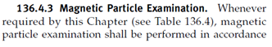
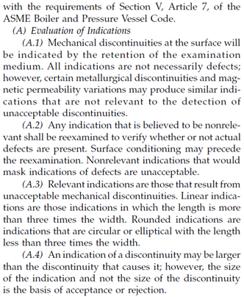

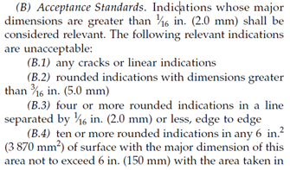
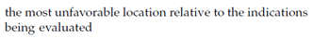
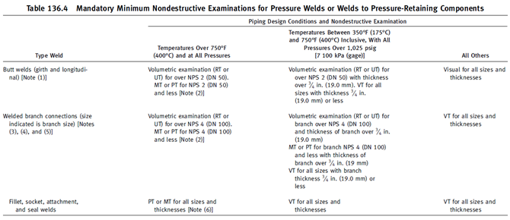

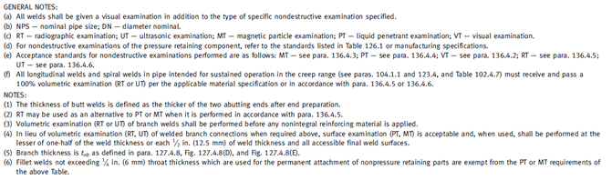

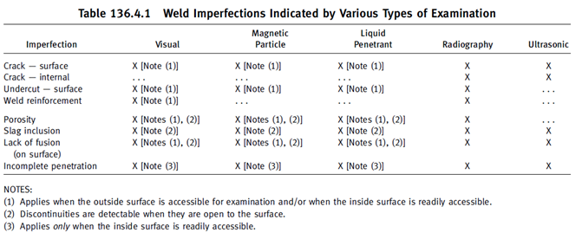

APPENDIX 2 - ASME B31.3 2014

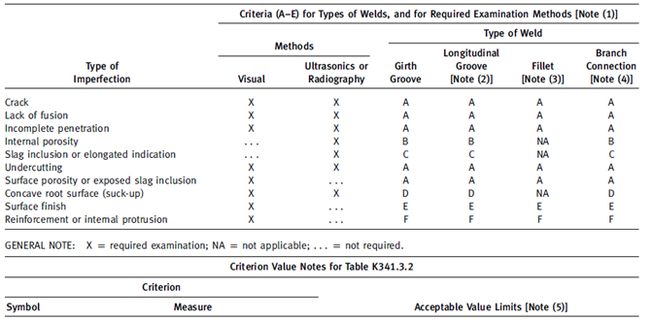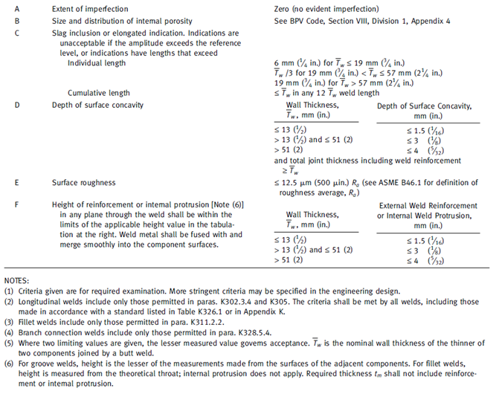

APPENDIX 3 - ASME VIII 2015

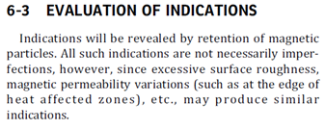
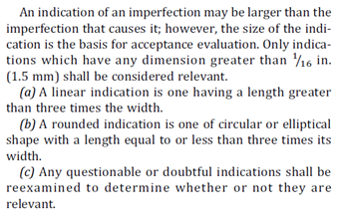
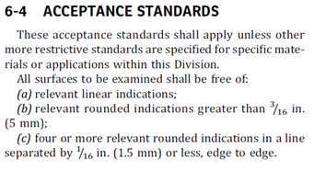

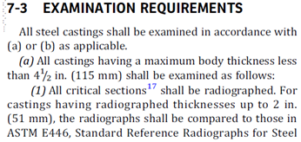
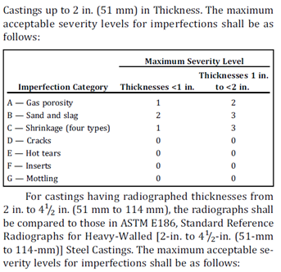
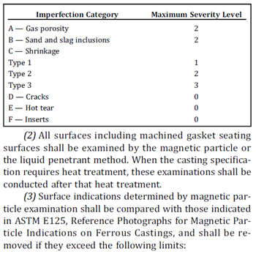
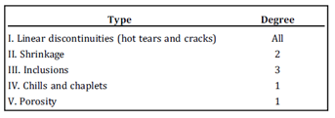

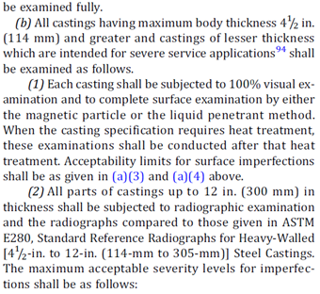
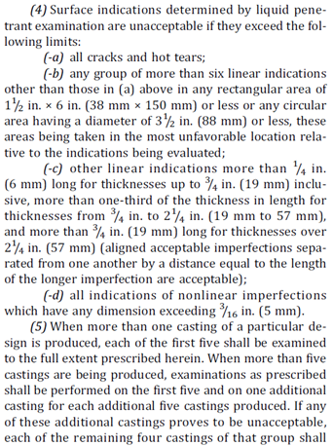
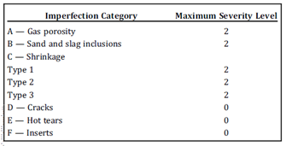
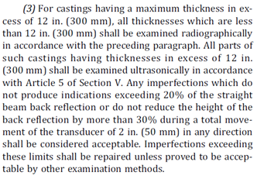

APPENDIX 4 - AWS D1.1 2010
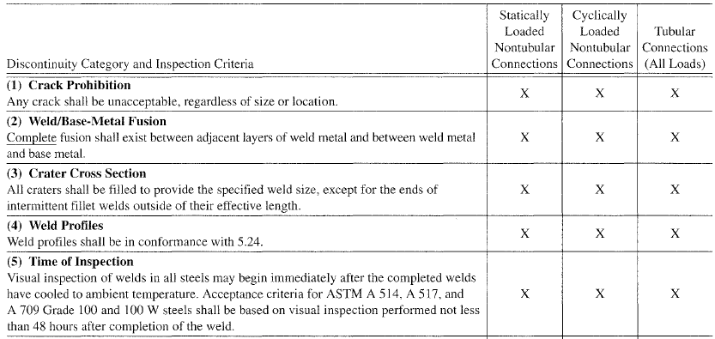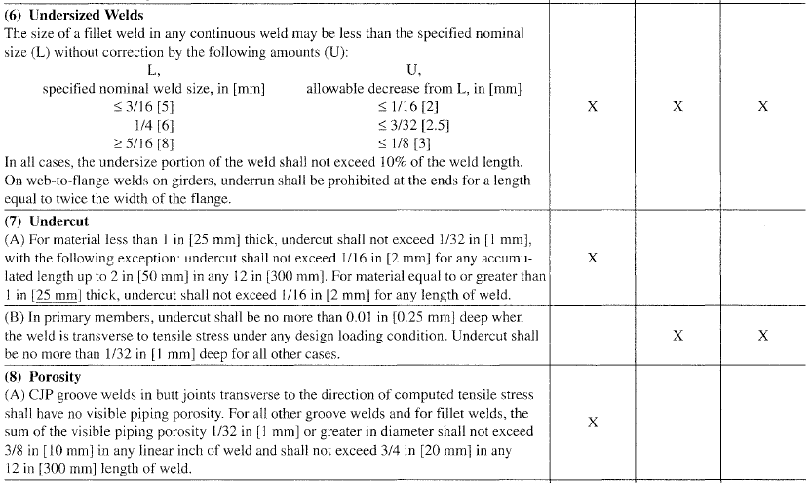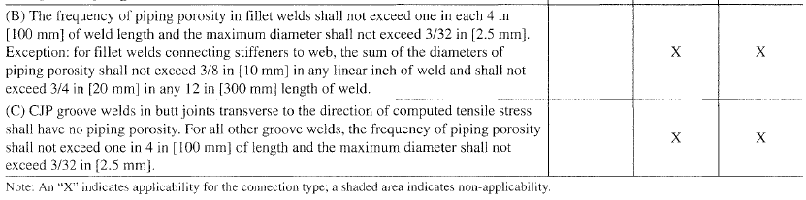

APPENDIX 5 - SAMPLE REPORT

